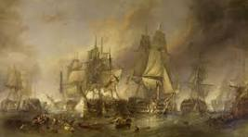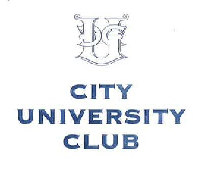

**TRAFALGAR BLACK TIE DINNER - Thursday 24th October 2024**

**6.45 pm for 7.15 pm**

**Cost £105 per person to include a Champagne reception,**

**3 course Dinner with Club Wines and Port**

## Speaker: **martyn downer - author**

Martyn Downer is a leading dealer of historic jewels, objects and artefacts, especially relating to the Royal Navy in the era of Admiral Lord Nelson. A former director and head of jewellery at Sotheby’s London, he is also founder of [My Family Silver](http://www.myfamilysilver.com/) the family crest and heirloom finding website.

Martyn has published four books including the bestselling *Nelson’s Purse* (Bantam Press, 2004) which recounted the story behind his discovery of a remarkable trove of lost treasures belonging to Admiral Nelson, and *Nelson’s Lost Jewel*(The History Press, 2017) which reveals the true story of Nelson’s fabled Chelengk jewel.

It will be a wonderful evening and members are advised to reserve their places as soon as possible. Bookings will be on a first come, first served basis and numbers will be limited to 20.

MENU

Ham Hock and Smoked Chicken Terrine, Spiced Fig and Apple Chutney, Toasted Sourdough

Roast Fillet of English Beef, Crispy Ox Cheeks and Horseradish Potato Cake, Honey Roasted Piccollo Parsnips and Carrots, Red Wine Jus

CUC Spotted Dick with Vanilla Custard

Coffee and Mints

£105