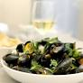

Tuesday 22 October 2024

Moules Frites Lunch

Dining Room Service

# Mussel Marinieres Served with French Fries and Crusty Bread

# ***

# Almond Tart, Mixed Fruit Compote, Chantilly Cream

£30