****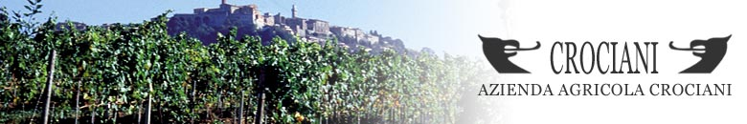

**WINE DINNER**

Will be conducted by Wine Grower Susanna Crociani with Dennis van Duuren of Ellis of Richmond

Susanna Crociani runs this much-respected winery and cantina in the region of Montepulciano. She came into the family business to work with her father.

The vineyards are located in Caggole just under two miles outside the main town and in the heart of Vino Nobile country.  Ancient lakes and streams left deposits of marine sediments embedded in the chalk and clay soils and is ideal for the growing of the three grapes varieties, Mammolo, Sangiovese and Caniolo, key components of Vino Nobile and Rosso di Montepulciano wines.

Every aspect of the viticulture is carried out by hand and the grapes are harvested and taken to a local cellar for pressing. The wine is then aged in fourteenth century cellars in the upper and historical part of the village of Montepulciano.

Susanna also makes Vin Santo, or ‘Holy Wine, first used in the celebration of mass in churches in the early 14th century.

Thursday 7 November - 6:30pm for 7pm

**Prosecco Le Monde on arrival**

Starter

Assorted Italian Breads served with Dishes of Balsamic Vinegar and Extra Virgin Olive Oil with Plated Assorted Antipasti

Rosso di Montepulciano Crociani 2022

Main

Spicy Italian Sausage and Bean Stew

Rosso d’Arnaldo, Toscano 2017

Vino Nobile di Montepulciano Crociani 2019

Dessert

Traditional Tiramisu

Vin Santo di Montepulciano Crociani 2019

**£60**