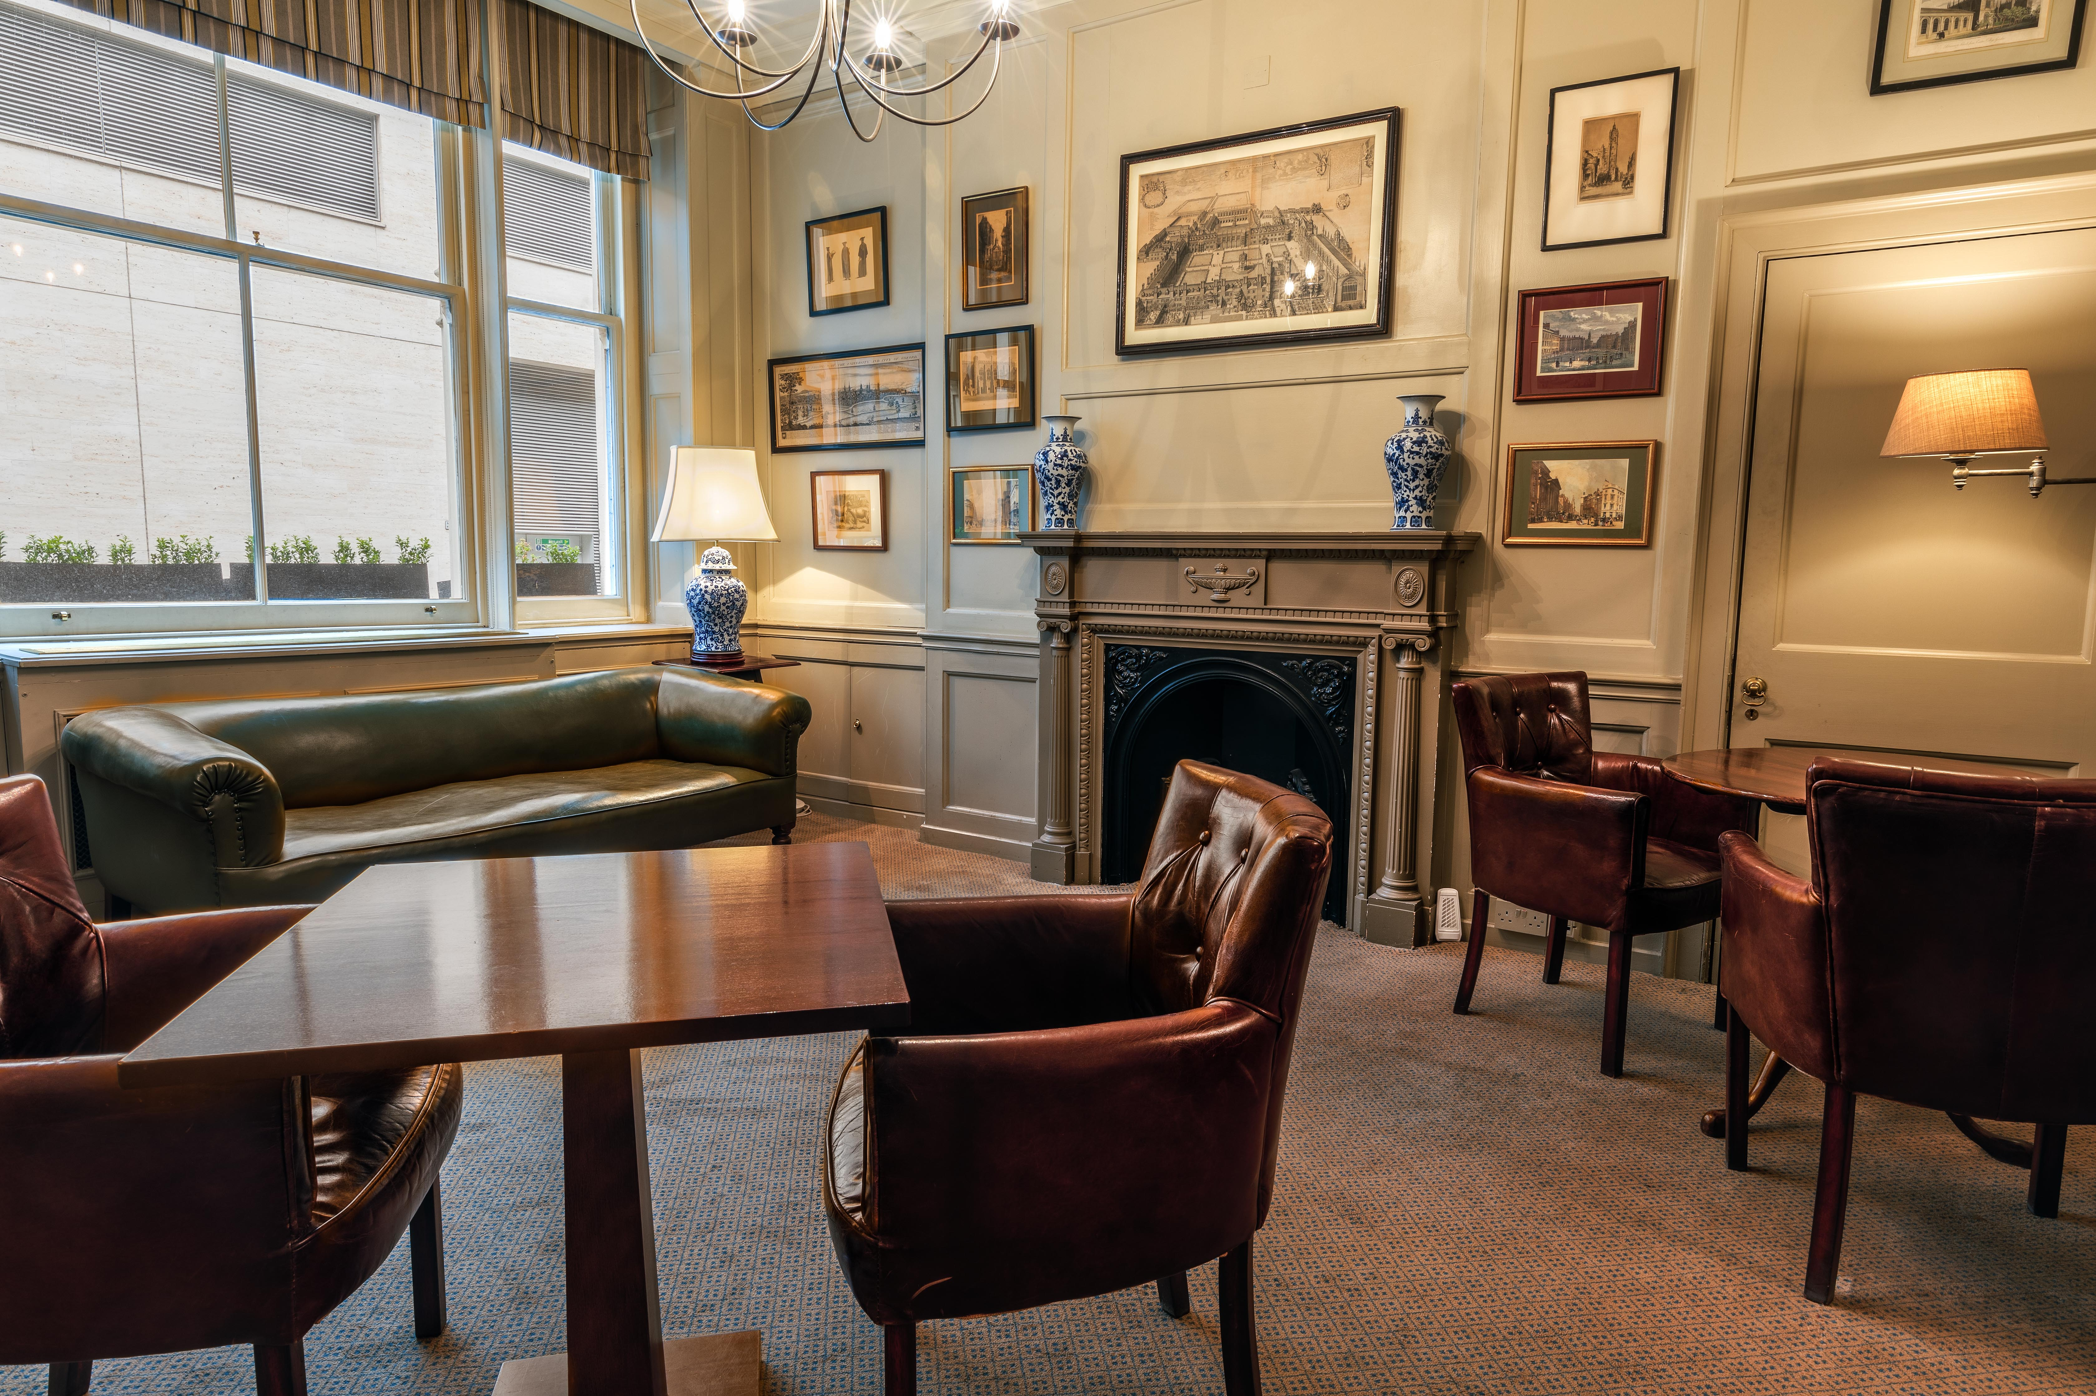

Young Members Dinner

6.30 for 7pm

Thursday 27th February 2025

Main

Pine Nuts and Basil Crusted Delice of Salmon, Crushed New Potato Cake, Garden Peas, Green Beans and Braised Baby Fennel laced With a Dill Fish Veloute

\*\*\*

Dessert

Warm Blueberry Frangipane Tart, Vanilla Ice Cream and Berry Compote

Half Bottle Wine

£40