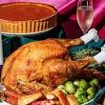

Thanksgiving Lunch

Thursday 28 November 2024

Dining Room Service

Menu

Roast Turkey, Stuffing, Sweet Potatoes, Cornbread Mash potato, Green Vegetables, Gravy and Cranberry sauce

\*\*\*

Pecan Pie and Chantilly Cream

£36.50