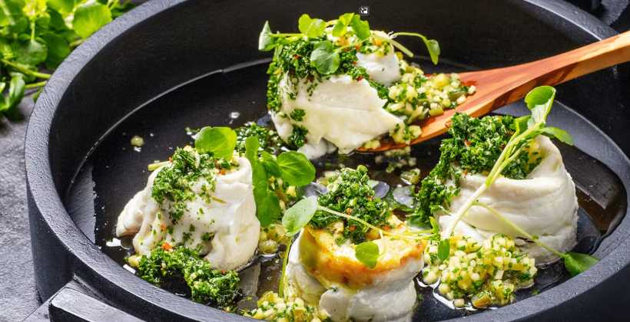

Younger Members Dinner

6.30 for 7pm

Thursday 31 October 2024

Main

Paupiette of Haddock served with Wilted Spinach, Parsley New Potatoes, Greens Beans and Garden Peas, Tempura Oyster and Dill Butter Sauce

\*\*\*

CUC Lemon and Lime Posset with Amaretto Biscuits

\*\*\*

Half Bottle Wine

£40