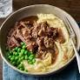

Liver and Bacon Lunch

Wednesday 30 April

Dining Room Service

Menu

Pan Fried Lambs Liver and Bacon, Rich Onion Gravy,

  Sauté Leeks, Savoy Cabbage and Champ Mash

\*\*\*

Homemade Bakewell Tart, Raspberry

Coulis, Chantilly Cream

£30