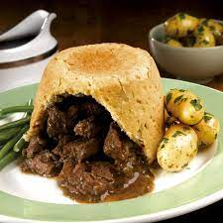

Steak & Kidney Pudding Lunch

Thursday 10 April

Dining Room Service

Menu

Homemade Steak and Kidney Pudding,

Sauté Cabbage, Root Vegetables, Mash,

Red Wine Jus

\*\*\*

Almond and Blackcurrant Tart, Berry Compote and Vanilla Ice Cream

£32